Feedforward and ratio control
In class activities
Ranjeet Utikar
2023-07-30

1. Activities
- Consider a boiler drum as shown in the figure below
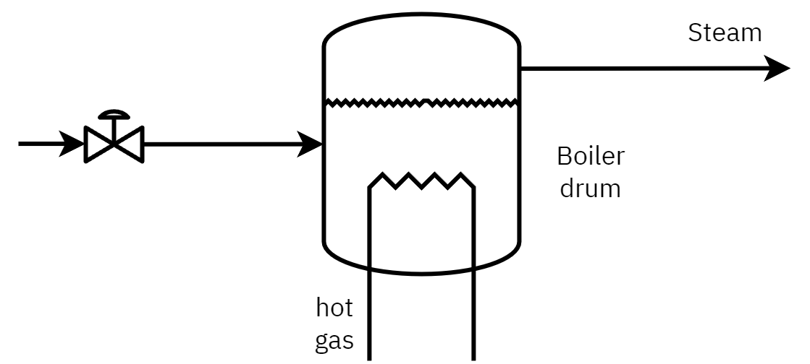
Figure 1: Boiler drum
- Identify controlled variable, manipulated variable and disturbance
- Draw a conventional feedback control to maintain liquid level in the boiler.
- What are the drawbacks of this system?

- Consider the operation of heat exchanger to demonstrate the application of feedforward control strategy. Identify all disturbances and the target disturbance to be remove using the feedforward control strategy
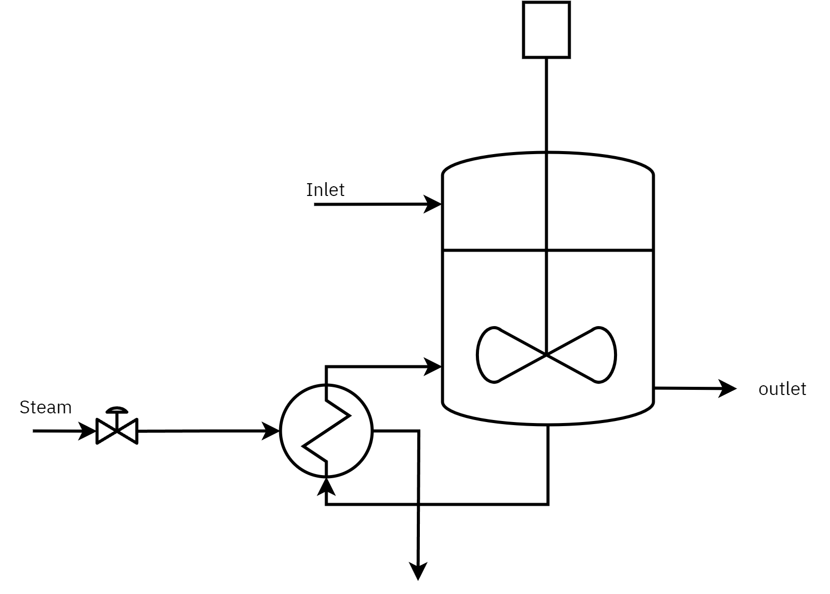
Figure 2: Heat exchanger

- For the blending system shown in Figure 3
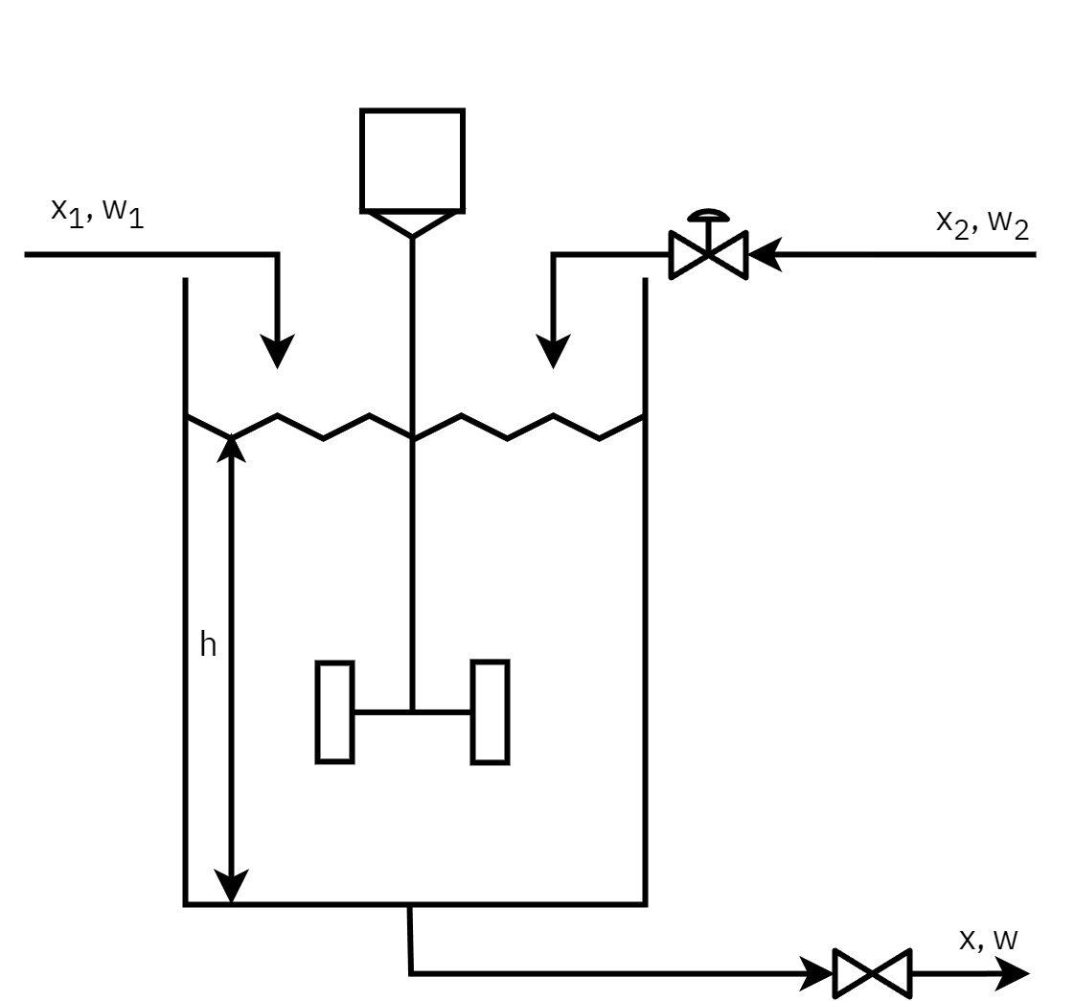
Figure 3: Blending system
- Identify controlled variable
- Manipulated variable
- Disturbance
- Propose a feedforward strategy to control outlet composition
- Propose a strategy to control composition when inlet flowrate $w_{2}$ is fluctuating
- propose a feedforward feedback control strategy

- The process, and disturbance transfer functions for problem 1 are given by
$$G_{p}\left(s\right)=\frac{0.1e^{−s}}{2.5s+1} \left(1\right)$$
$$G_{d}\left(s\right)=\frac{0.5e^{−s}}{2.5s+1} \left(2\right)$$
- use PID tuner app to tune a PID controller for this process.
- Propose a feedforward control system for Figure 1. Explain how a feedforward control can improve disturbance rejection or regulatory control performance.
- Calculate ideal feedforward compensator for Problem 2 and implement pure feedforward control scheme in simulink.
- Draw a combined feedforward-feedback PID for Figure 1. Implement feedforward-feedback system in simulink.
- Consider the following process and disturbance transfer functions:
$$\text{ Process: }G_{p}\left(s\right)=\frac{2exp\left(−4s\right)}{15s+1} \left(3\right)$$
$$\text{Disturbance: }G_{d}\left(s\right)=\frac{5exp\left(−2s\right)}{30s+1} \left(4\right)$$
- Do the following:
  - For the process given above, can an idealized feedforward controller be used to reject the disturbance.
  - Obtain a feedforward controller and PID controller for the process above using the unified feedforward-feedback control method.
- Ratio control for ammonia synthesis reactor.

- Furnace ratio control Figure 4
- Draw the schematic of a ratio control strategy. What is the target disturbance? What is the manipulated variable? What is the controlled variable?
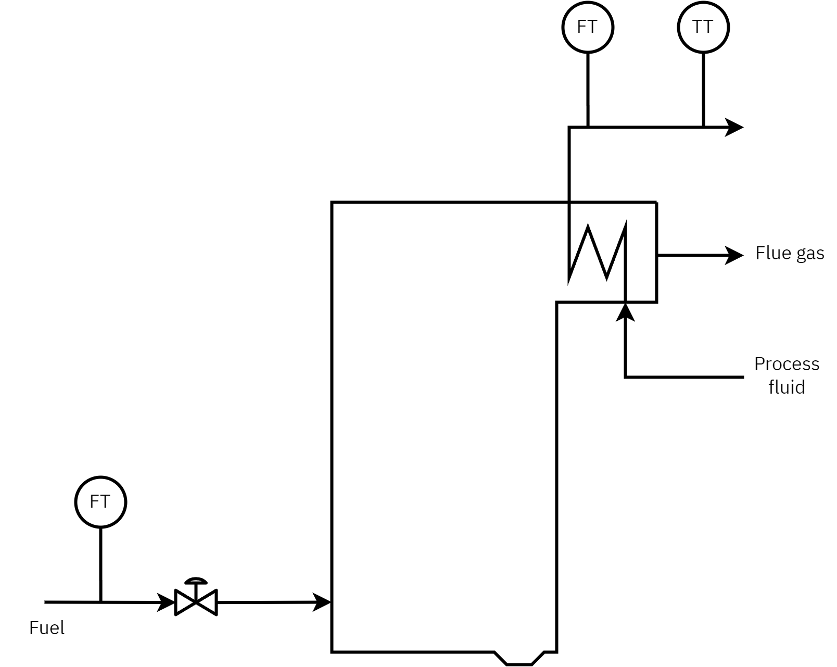
Figure 4: Furnace

- Wastewater pH neutralization Figure 5
- Devise a ratio control strategy to provide desired flow rate of NaOH solution to maintain the pH of the effluent.
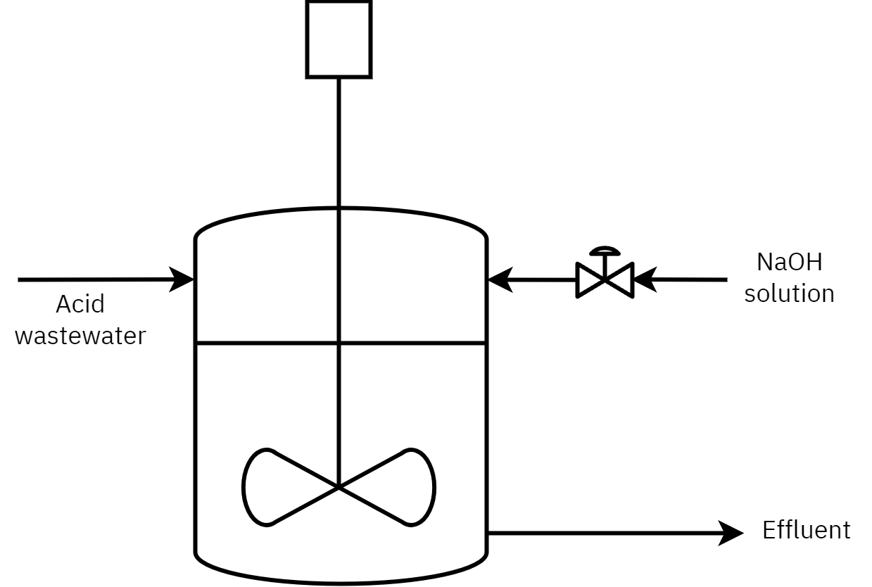
Figure 5: Wastewater treatment tank

