Ratio control: Ammonia synthesis reactor
Lecture notes for Advanced modeling and Control
Ranjeet Utikar
2023-07-26

1. Example 15.1 from (Seborg et al. 2016)
A ratio control scheme is to be used to maintain a stoichiometric ratio of H₂ and N₂ as the feed to an ammonia synthesis reactor Figure 1. Individual flow controllers will be used for both the H₂ and N₂ streams. Using the information given below,
- Draw a schematic diagram for the ratio control scheme.
- Specify the appropriate gain for the ratio station, $K_{R}$.

1.1 Available information:
- The electronic flow transmitters have built-in square root extractors. The spans of the flow transmitters are 30 L/min for H₂ and 15 L/min for N₂.
- The control valves have pneumatic actuators.
- Each required current-to-pressure (I/P) transducer has a gain of 0.75 psi/mA.
- The ratio station is an electronic instrument with 4–20 mA input and output signals.
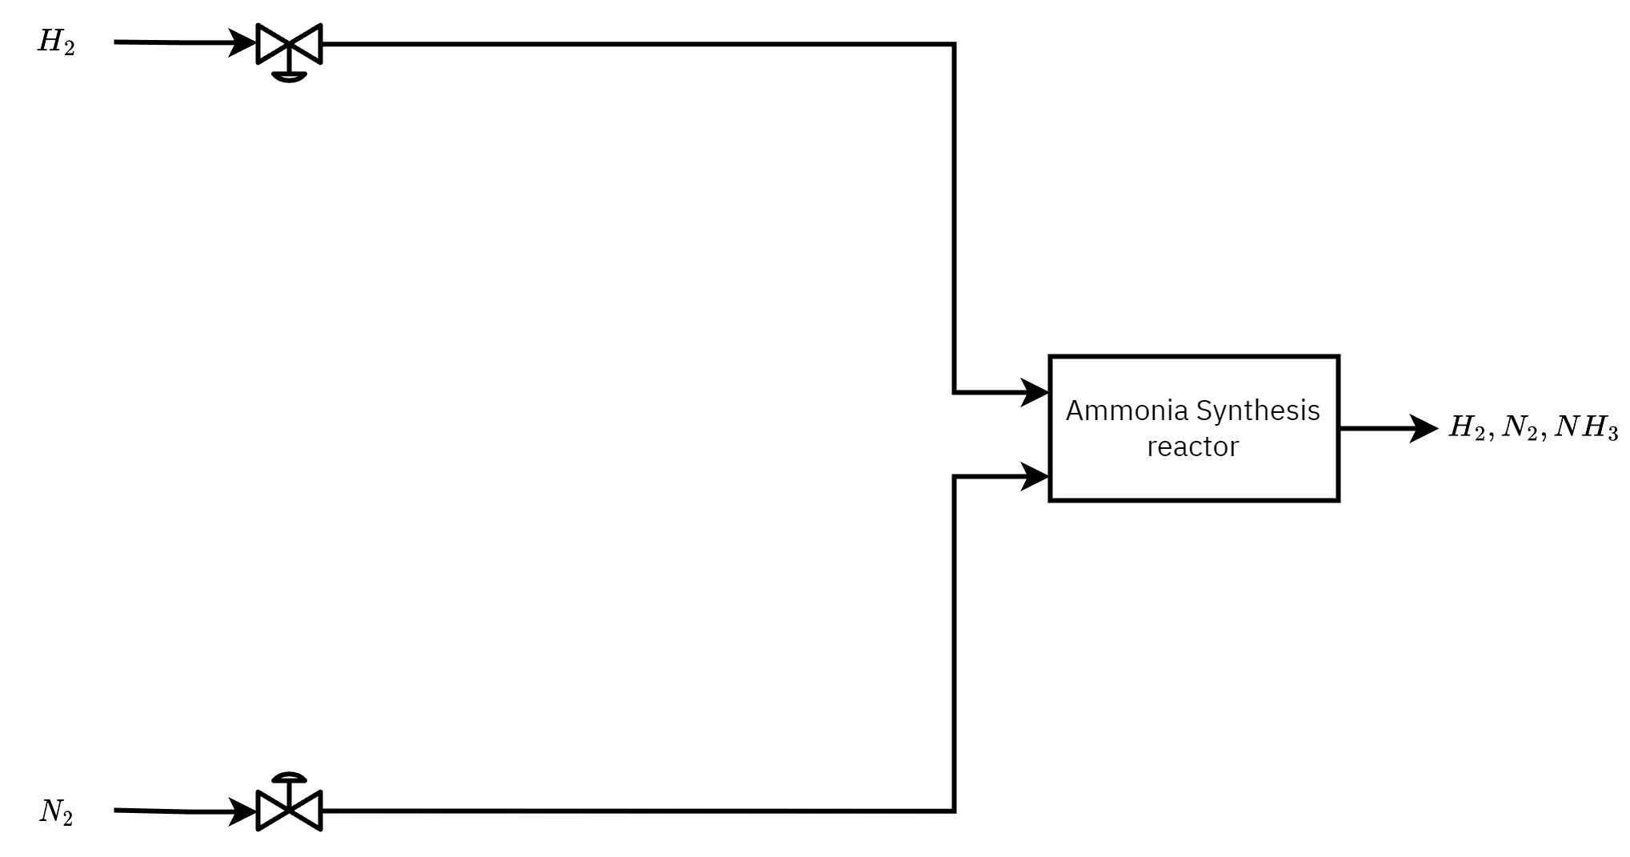
Figure 1: Ammonia synthesis reactor

1.2 References
Seborg, Dale E., Thomas F. Edgar, Duncan A. Mellichamp, and Francis J. Doyle III. 2016. Process Dynamics and Control. John Wiley & Sons. https://books.google.com?id=ZZVFEAAAQBAJ.

