Lab 07: PLS Modelling
CHEN4011: Advanced modeling and Control
Ranjeet Utikar
2023-10-02

1. Objectives
- To develop PLS models using plsregress function.
- To compare the PLS model predictive accuracies for different input shapes:
- Uniform random numbers for sampling periods T_{s}=0.5 and T_{s}=1.5
- Sequential step changes for sampling periods T_{s}=0.5 and T_{s}=1.5
- To implement the PLS models as soft sensors for y₁ and y₂

2. Problem Statement
Figure 1 shows a distillation process that is represented using the Simulink model. The outputs (responses) are the distillate product impurity y₁ and bottom product impurity y₂. There are 3 measured state variables: x₁ and x₂ are tray temperatures while x₃ is column pressure. Also, there 3 measured inputs: u₁ is feed flow rate, u₂ reflux flow rate and u₃ steam flow rate to the distillation boiler. Note that both response variables y₁ and y₂ are difficult to measure but their values must be kept with acceptable ranges. Also note that, the values shown by the Simulink model simulation are based on the nominal operating values, not the absolute values. As a process control engineer in your company, you are responsible for the profitable operation of the distillation column. To enable tight control of the two response variables, you have decided to build two soft sensors for measuring the variables. The soft sensors are developed using the well-known PLS models.
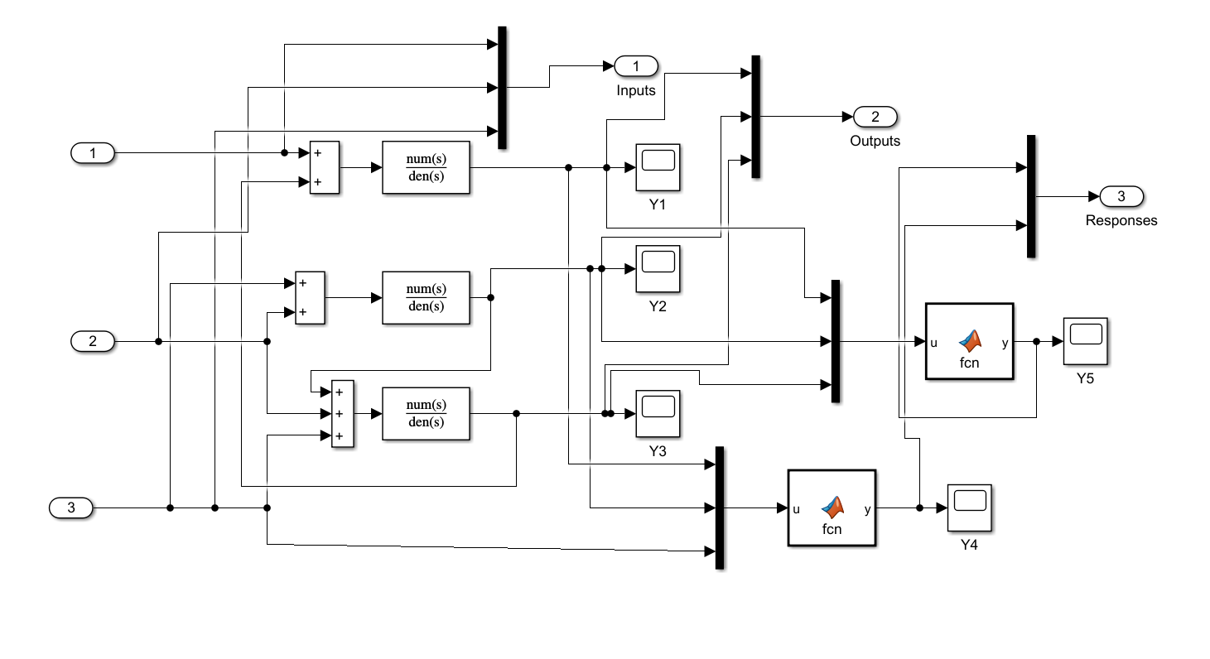
Figure 1: Distillation process: distillate impurity y₁ and bottom product y₂.

3. Tasks
- Construct several PLS models using the plsregress function in Matlab for the different input shapes and sampling periods. Tabulate the regression coefficients and MSE values of all PLS models. [3 marks]
- Compare the PLS modelling accuracies based on the MSE values. Comments on the impact of input shapes and sampling periods on the modelling accuracies. [3 marks]
- Implement 2 of your best PLS models on the given Simulink model. Run the simulation for some input changes (you may mix both shapes, e.g., step tests for inputs 1 and 2, and random number for input 3). Plot the actual and predicted profiles of the response variables. Comments on the results. [4 marks]

