Lab 03: Override Control
CHEN4011: Advanced modeling and Control
Ranjeet Utikar
2023-08-13

1. Objectives
- To demonstrate the application of a Low Select (LS) control strategy for protecting heat exchanger tube from overheating due to excessive heating.
- To develop MATLAB Simulink model for the LS control strategy

2. Problem Statement
A process fluid is heated using steam in a heat exchanger.
If the process fluid flow rate is suddenly increased, there will be a large drop in the process fluid temperature T. To bring back the temperature to a setpoint, the heat transfer to the process fluid has to be increased. Since U and A are fixed, then the only way for Q to increase is that T_{s} (tube skin temperature) has to be increase. The danger is that increase in T_{s} beyond a maximum limit (depending on the tube material) will cause the tube be damage by overheating. Therefore, to prevent this situation, an override control is needed.
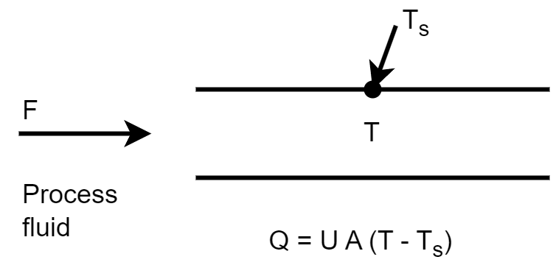
Figure 1: Heat transfer in a heat exchanger
Consider the following two transfer function below, which represent the process fluid and the heat exchanger tube temperatures. The LS control strategy is used to protect the heat exchanger tube from overheating in the face of an excessive flow rate of steam into the heat exchanger.
Process fluid temperature transfer function
$$G_{p}\left(s\right)=\frac{4exp\left(−2s\right)}{\left(7s+1\right)} \left(1\right)$$
Heat exchange tube temperature transfer function:
$$G_{e}\left(s\right)=\frac{3exp\left(−1.5s\right)}{\left(6s+1\right)} \left(2\right)$$
Assume that at the steady-state condition, the nominal values for the process fluid and exchanger tube temperatures are 300°C and 350°C. The maximum allowable skin temperature is 400°C.

3. Report Format
The report should be no more than 5 pages excluding the cover page.
The report should cover the following:
- Provide the MATLAB Simulink model and a clear explanation about the model, e.g., what factor/s can you simulate. [3 marks]
- Answer the following questions:
  - Explain under what (possible condition) the LS control will choose the command from the tube temperature controller? [2 marks]
  - Discuss what will happen if the process gain of the tube temperature transfer function changes, e.g., increases by 10% or decreases by 10%? [2.5 marks]
  - Discuss what will happen if the process time constant of the process fluid temperature transfer function changes, e.g., increases by 10% or decreases by 10%? [2.5 marks]

